**Name:** Raja Danyal Mushtaq **Email:** rajadanyal.fui@gmail.com

**Hand-on Exercise:** 01 **Batch:** 05 WordPress

Problem Statement

First choose domain name of your website then install WordPress on the server. Change default theme and add a home page.

danidigiSkilllearning was the domain name I have chose.

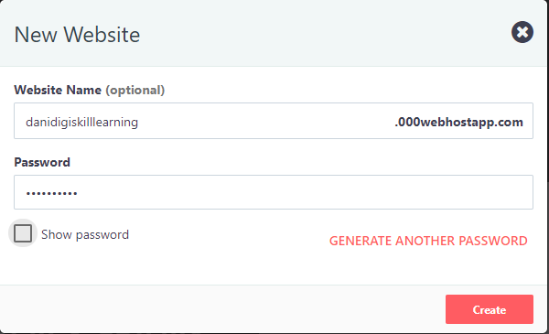

Installing WordPress on the hosting server

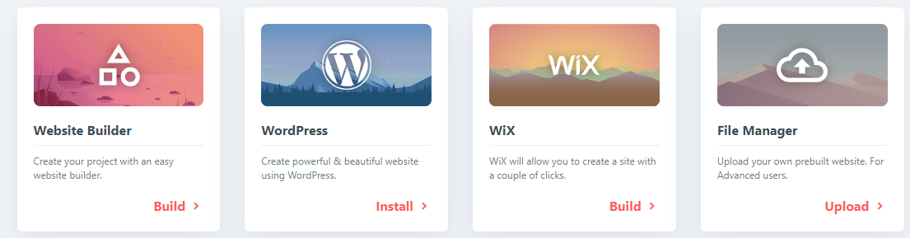

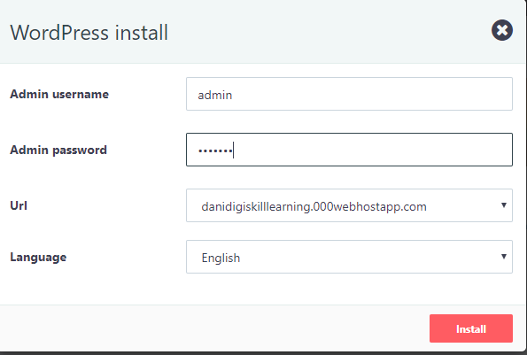

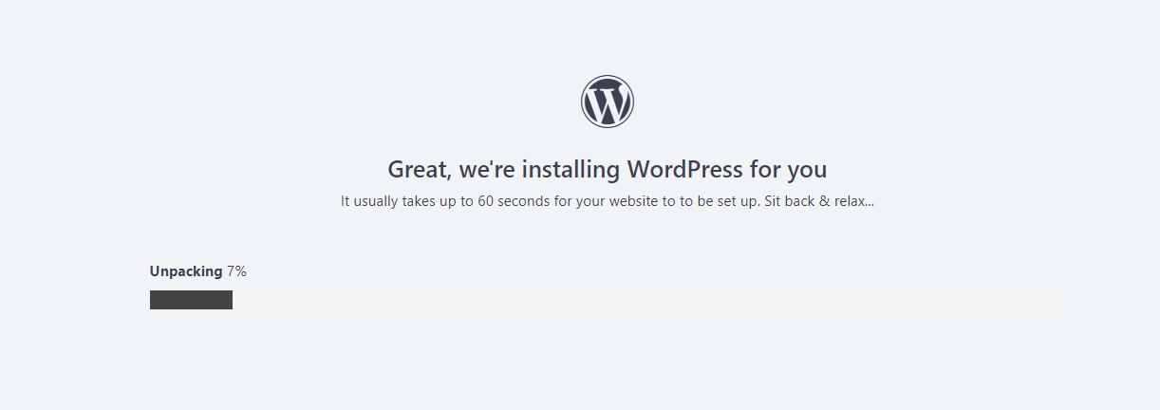

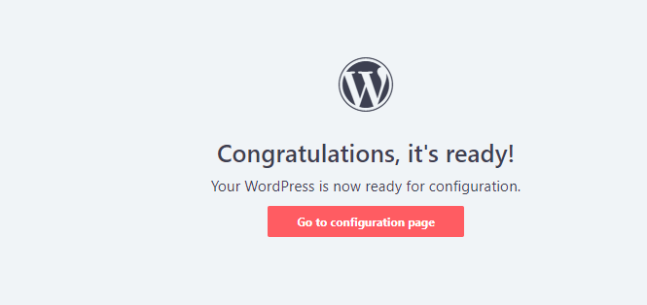

First login to the WordPress open dashboard for changing the appearance of website.

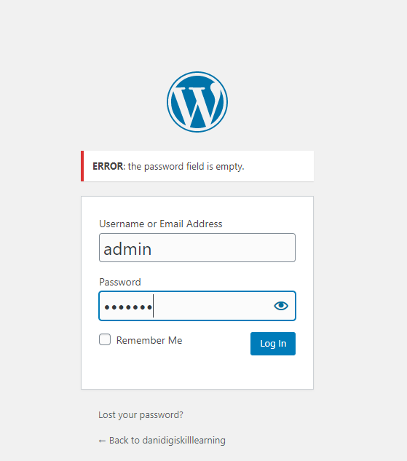

I have selected the theme blogshop



After applying theme website look like this.

